Guide for People who are Deaf or Hard of Hearing
This guide describes accessibility features built into Windows and Microsoft Office, as well as different types of assistive technology products that are designed for individuals who are Deaf or Hard of Hearing. Note that some sections of this guide may be useful to individuals with different types of disabilities like learning or mobility.
Microsoft wants to provide the best possible experience for all our customers. If you have a disability or have questions related to accessibility, please contact the Microsoft Disability Answer Desk for technical assistance. The Disability Answer Desk support team is trained in using many popular assistive technologies and can offer assistance in English, Spanish, French, and American Sign Language. To learn more about our ASL Technical Support please check out a new promotional video, Windows 10 Anniversary Update tech support available in ASL. If you are a government, commercial, or enterprise user with questions or feedback about accessibility, please contact the Enterprise Disability Answer Desk.
At Microsoft, our mission is to empower every person and organization on the planet to achieve more. We are committed to delivering great experiences and customer service to people with disabilities. If you have feedback to offer, or requests to make of us, we encourage you to let us know through the Microsoft Accessibility Forum.

In this section:
Setup Accessibility Options in Windows
Accessibility in Microsoft Office
Change Sound Settings in Windows
Hearing Solutions with Skype
Find Assistive Technology for People who are Deaf or Hard of Hearing

Setup Accessibility Options in Windows
Ease of Access is a location where you can set up accessibility settings and programs available in Windows.

Turn on Ease of Access options
With Windows you can access commonly used accessibility options right from the sign-in screen. Press the Windows Logo Key + U to access the Ease of Access settings at the sign-in screen. There you can start up Narrator, Magnifier, or the On-Screen Keyboard. You also have the option of turning High Contrast, Sticky Keys, or Filter Keys on and off. These are just some of several accessibility features that Windows offers.
After you log on, you can also open Ease of Access by pressing the Windows Logo Key + U.
Caption 1: Ease of Access settings with Closed Captions section selected
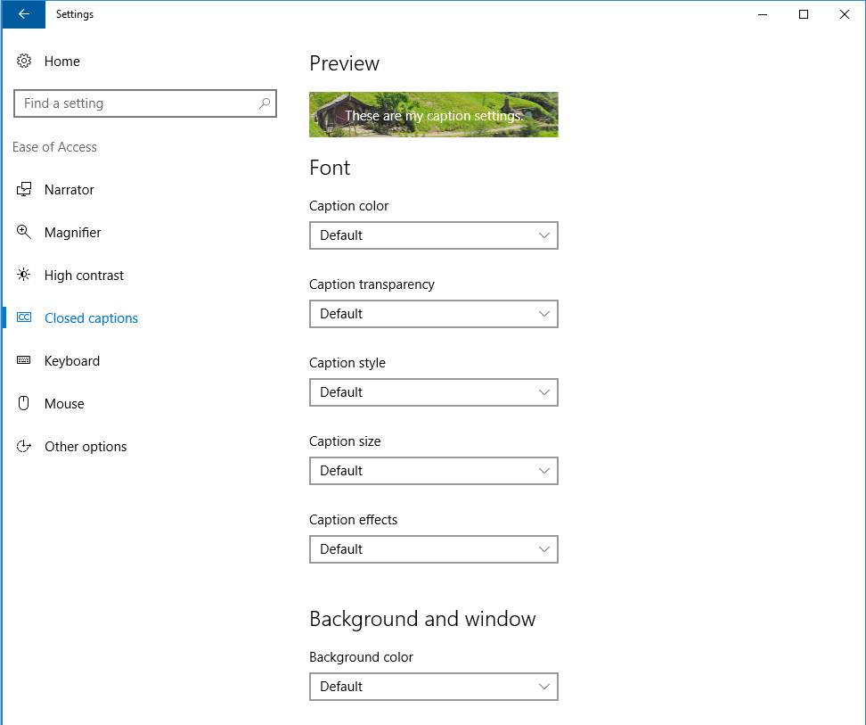
To open Ease of Access on a touch-enabled device,
- Swipe in from the right edge of the screen.
- Select All Settings.
- Select Ease of Access.
Learn more about Ease of Access

Customize closed captions
Windows lets you customize the way that closed captions appear when you watch a movie or TV show in some Windows apps, such as the Movies & TV app. Adjust closed captioning options in Settings.
- Open Ease of Access by pressing the Windows Logo Key + U
- Select Closed Captions.
Learn more about Closed Captions in Movies and TV for Windows 10

Adjust notification settings
You can choose to have the active window, active title bar, or the whole screen flash when a notification arrives instead of relying on sound alone. By default, Windows notifications disappear five seconds after they appear.
- Open Ease of Access by pressing the Windows Logo Key + U
- Select Other options
- Choose how long to Show notifications for or your Visual notifications for sound preferences.
Caption 2: An example of some of the Visual options and Touch feedback you can get in Windows
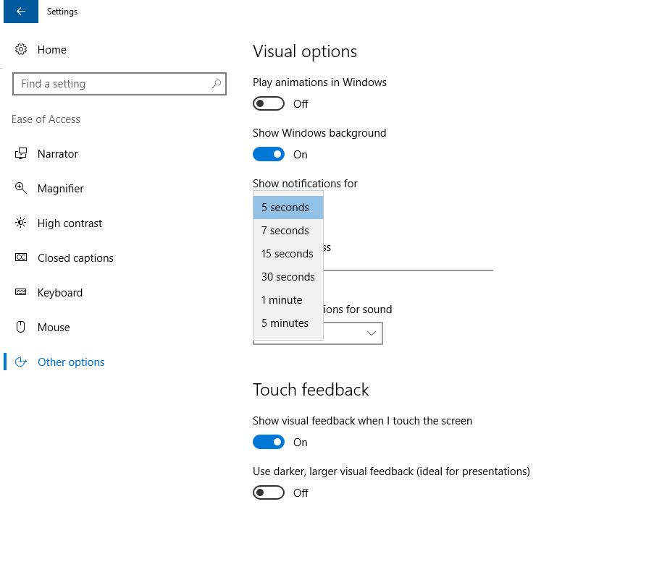

Accessibility in Microsoft Office
Built-in features in Microsoft Office can help you make your documents, spreadsheets, and presentations accessible to individuals who are Deaf or Hard of Hearing. For more information on creating accessible content, please visit Accessibility in Office 2016 and Windows 10. Check back regularly as we frequently add new articles and product tutorials.

Accessibility Checker
Word, Excel, PowerPoint, and OneNote include an Accessibility Checker that identifies some content that might be inaccessible to individuals with disabilities. You can use the Accessibility Checker while you author to inspect errors as they occur and learn how to fix issues.
To Open the Accessibility Checker:
- Press Alt + F to open the File menu.
- Select Info.
- Select Check for Issues.
- Select Check Accessibility.
Caption 3: Accessibility Checker with Closed Captions error
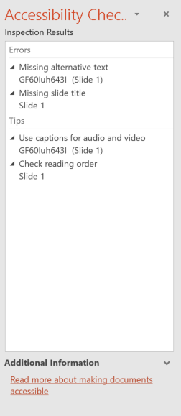
Learn more about the Accessibility Checker
Learn more about the Accessibility Checker on the Mac

Get keyboard shortcuts and steps for using assistive technology with Office
Office for Windows, Online, Mac, iOS, Android, and Windows Mobile provides support for individuals who are Deaf or Hard of Hearing. You can read about the accessibility features for your specific environment at the Office Accessibility Center. There you can get all the latest accessibility information on products such as Word, PowerPoint, Excel, Outlook, and even others outside of the Office Suite such as Skype or OneDrive.
- Visit the Office Accessibility Center.
- Select the app you want to learn about.
- Navigate to the section for your device.

Change visual notifications in Outlook
There are several different ways that a user can get notified with a new message. When you receive a message, you can make it so the mouse pointer changes or an envelope icon shows up in the taskbar. Here are a series of short steps that can be followed in the Outlook 2016 program.
- Select File
- Select Options
- Select Mail
- Scroll down to the Message Arrival section and select from the following options.
- Play a sound
- Briefly change the mouse pointer
- Show an envelope icon in the taskbar
- Display a Desktop Alert
  - Enable preview for Rights Protected messages (May impact performance)
Caption 4: “Message arrival” options under “Outlook Options” highlighted
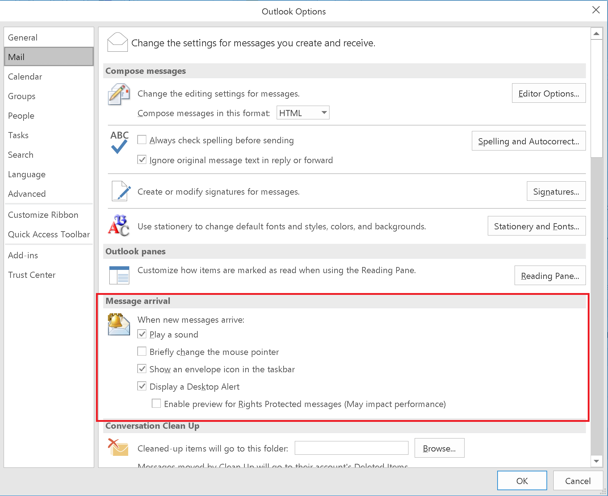

Adding closed captions to Office Mix
Office Mix is an add-in for Microsoft PowerPoint that allows you to create, edit, and share interactive online videos. To add Closed Captioning to a mix:
- Download and install the Office Mix add-in.
- Open PowerPoint and select the Mix tab (ALT + Y2).
- Choose video content then select Upload to Office Mix
- Check the box Create a video so viewers can watch this mix offline and on mobile devices.
- Select Show me my mix.
- Download the video and utilize a third-party service to create the TTML file from your video.
- Upload the TTML file associated with your mix
Caption 5: Upload to Mix pane in PowerPoint
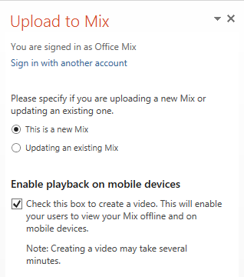
Learn more about adding Closed Captions to an Office Mix

Change sound settings in Windows

Adjust computer volume
Although most speakers have a volume control, you can also control speaker volume using Windows. The quickest way to change the speaker volume for your computer is to select the Speakers button in the notification area, and then to move the slider right or left to increase or decrease the speaker volume.
Caption 6: Computer volume control slider in Windows
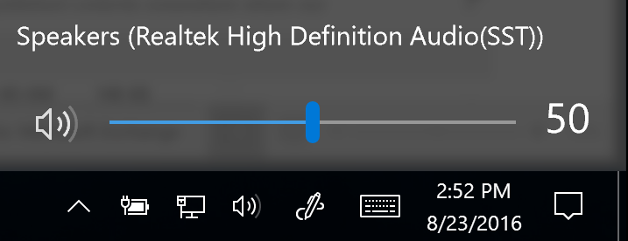
Alternatively, you can right-click on the Speakers button in the notification area and select Open Volume Mixer. The volume for the Device and Applications can be adjusted from there.
Caption 7: Volume Mixer in Windows
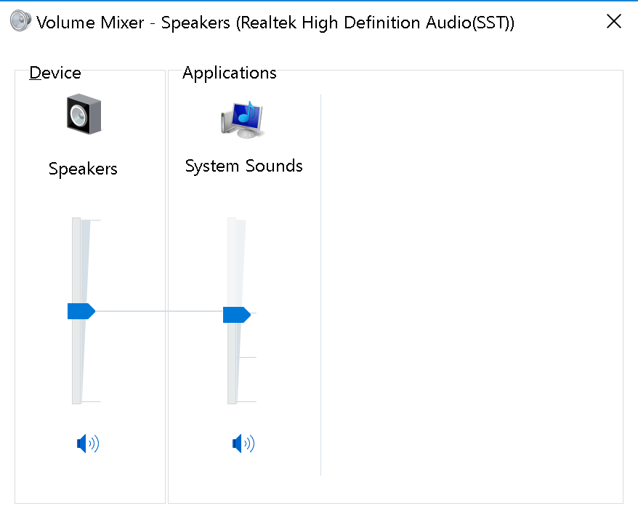

Change computer sounds
You can have your computer play a sound when certain events occur on your computer. An event can be an action that you perform, such as logging on to your computer, or an action that your computer performs, such as alerting you when you receive new email.
Windows comes with several sound schemes for common events. Additionally, some desktop themes have their own sound schemes. To change sound schemes:
- Right-click the Speakers icon in the notification area.
- Select Sounds.
- Select the program events and associated sounds you want to comprise a new sound scheme.
Caption 8: Sound dialog box open to the Sounds tab
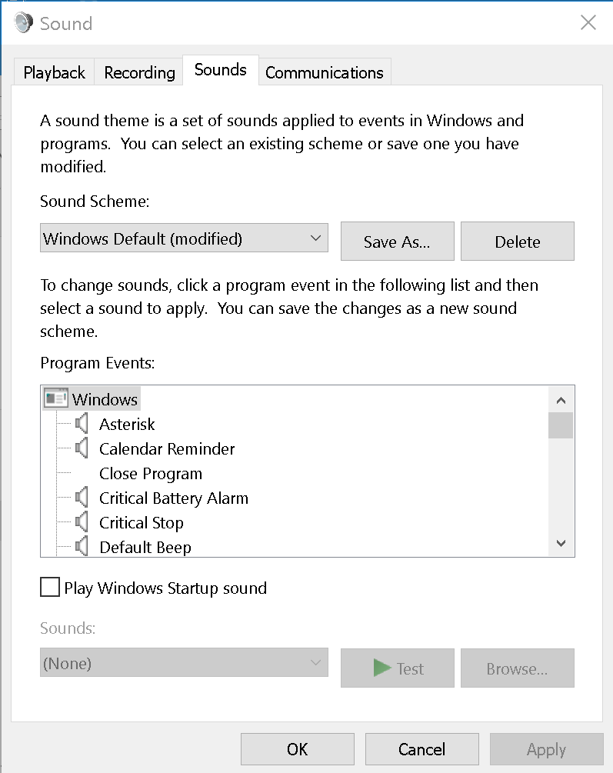

Hearing solutions with Skype
Depending on the learning or work environment, individuals may be able to use Skype Translator, to communicate via text rather than spoken dialogue with classmates or workmates in real time.
Caption 9: Instant messaging using Skype Translator
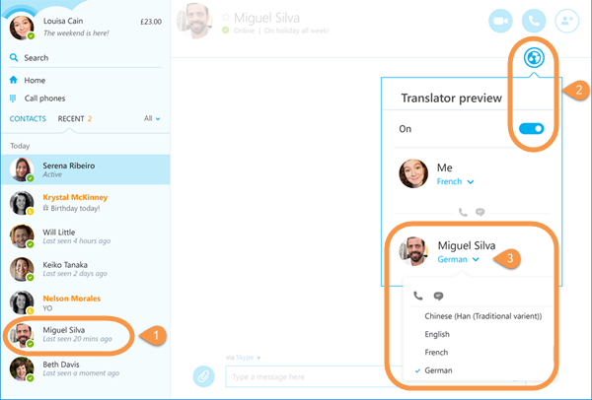

Setup Skype Translator to caption calls
- Select your contact.
- Select the Skype Translator/Globe icon and turn it on.
- Select your contact's current language under their name, and from the drop down, choose the language for translation while instant messaging or to hear the translations while in a call.
Skype Translator provides a single interface that unites voice communications, instant messaging, and audio, video, and web conferencing.

Find assistive technology for People who are Deaf or Hard of Hearing
You can shop for assistive technology products compatible with Microsoft Windows made by independent assistive technology companies. People who are Deaf or Hard of Hearing may be interested in the following assistive technology:
- Sign language interpretation is useful for students and others who are deaf or hard of hearing to enable them to actively communicate in the classroom and other settings.
- Personal listening devices and personal amplifying products can also be helpful for people who are deaf or hard of hearing.
- Sign language translators such as iCommunicator which is a graphical sign language translator that converts speech to sign language in real time, can enable people who are deaf or hard of hearing to communicate more easily with people who aren’t fluent in sign language.
- CART is a service for Skype for Business that takes a live visual transcript of conversations and enables people to communicate easier. Make your meeting more accessible with Skype for Business.
- Captioning Matters is a site that promotes broadcast captioning and CART captioning. Learn more about Captioning Matters.
Guide last updated on 2/7/2017.

