Guide for People who are Blind or Low Vision
This guide describes accessibility features built into Windows and Microsoft Office, as well as different types of assistive technology products that are designed for individuals who are Blind or Low Vision. Note that some sections of this guide may be useful to individuals with different types of disabilities like learning or mobility.
Microsoft wants to provide the best possible experience for all our customers. If you have a disability or have questions related to accessibility, please contact the Microsoft Disability Answer Desk for technical assistance. The Disability Answer Desk support team is trained in using many popular assistive technologies and can offer assistance in English, Spanish, French, and American Sign Language. Please go to the Microsoft Disability Answer Desk site to find out the contact details for your region. If you are a government, commercial, or enterprise user, please contact the Enterprise Disability Answer Desk.
At Microsoft, our mission is to empower every person and organization on the planet to achieve more. We are committed to delivering great experiences to people with disabilities. If you have feedback to offer, or requests to make of us, we encourage you to let us know through the Microsoft Accessibility Forum.

In this Guide:
Setup Accessibility Options in Windows
Make Accessible Documents with Office
Use Accessibility Features in Office
Browse the Accessibility Features of Internet Explorer and Edge
Find Assistive Technology for People who are Blind or Low Vision

Setup Accessibility Options in Windows
Ease of Access is a location where you can set up accessibility settings and programs available in Windows.
Learn more about Ease of Access

Turn on Ease of Access options
With Windows you can access commonly used accessibility options right from the sign-in screen. Press the Windows Logo Key + U to access the Ease of Access settings at the sign-in screen. On many keyboards, the Windows Logo Key is located on the bottom row of keys, to the left or right of the Alt key. There you can turn on or off Narrator, Magnifier, On-Screen Keyboard, High Contrast, Sticky Keys, or Filter Keys.

Caption 1: Ease of Access options on the Windows sign-in screen
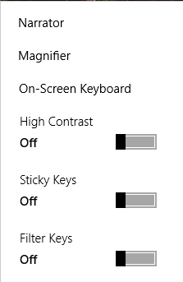
After you log on, you can open Ease of Access settings by pressing the Windows Logo Key + U.
To open Ease of Access settings on a touch-enabled device, swipe in from the right edge of the screen and select All Settings > Ease of Access.
Caption 2: Ease of Access settings with Narrator section selected
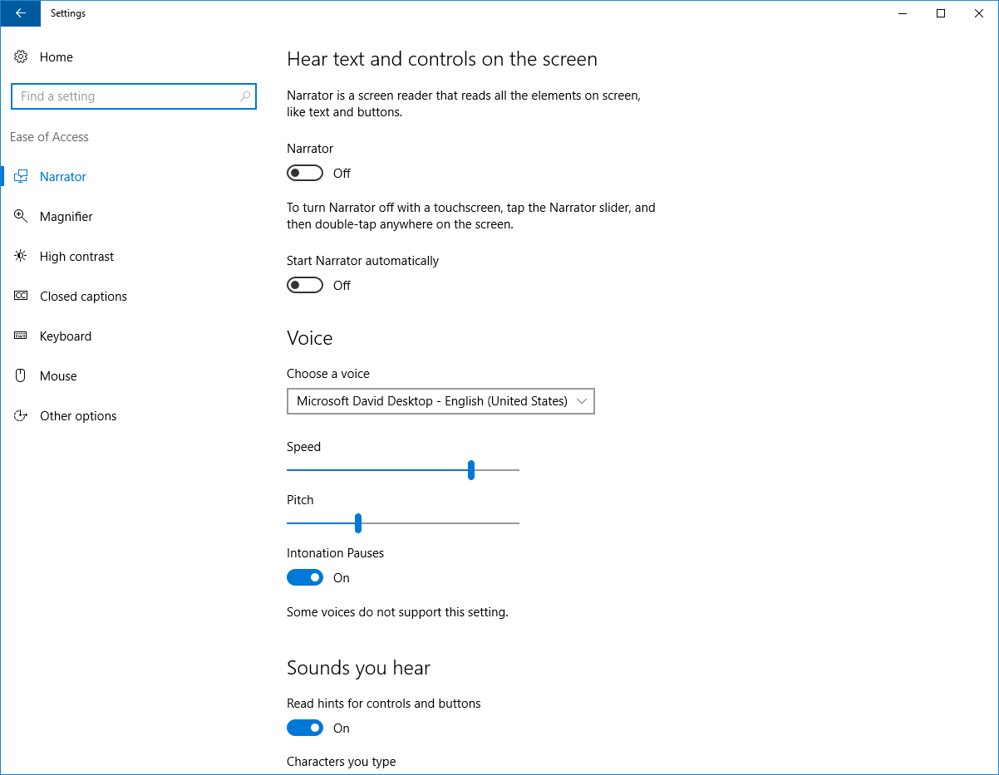

Hear text read aloud with Narrator
Narrator is the built-in screen reader that reads text on your screen aloud and describes events, such as notifications or calendar appointments. To start or stop Narrator, press the Windows Logo Key + Enter. On Windows Mobile devices, press Windows Logo Key + Volume UP key to toggle Narrator on/off.
Learn more about Narrator

Use Magnifier to see items on the screen
Magnifier is a tool that enlarges your screen so you can see words and images better. You can magnify the entire screen, or just a portion of it and move the magnifier where you want it on your desktop. To turn on Magnifier and Zoom in, press Windows Logo Key + Plus (+). To Zoom out, press Windows Logo Key + Minus (-). To exit Magnifier, press Windows Logo Key + Esc.
Learn more about Magnifier
Caption 3: Magnifier open on the Windows desktop

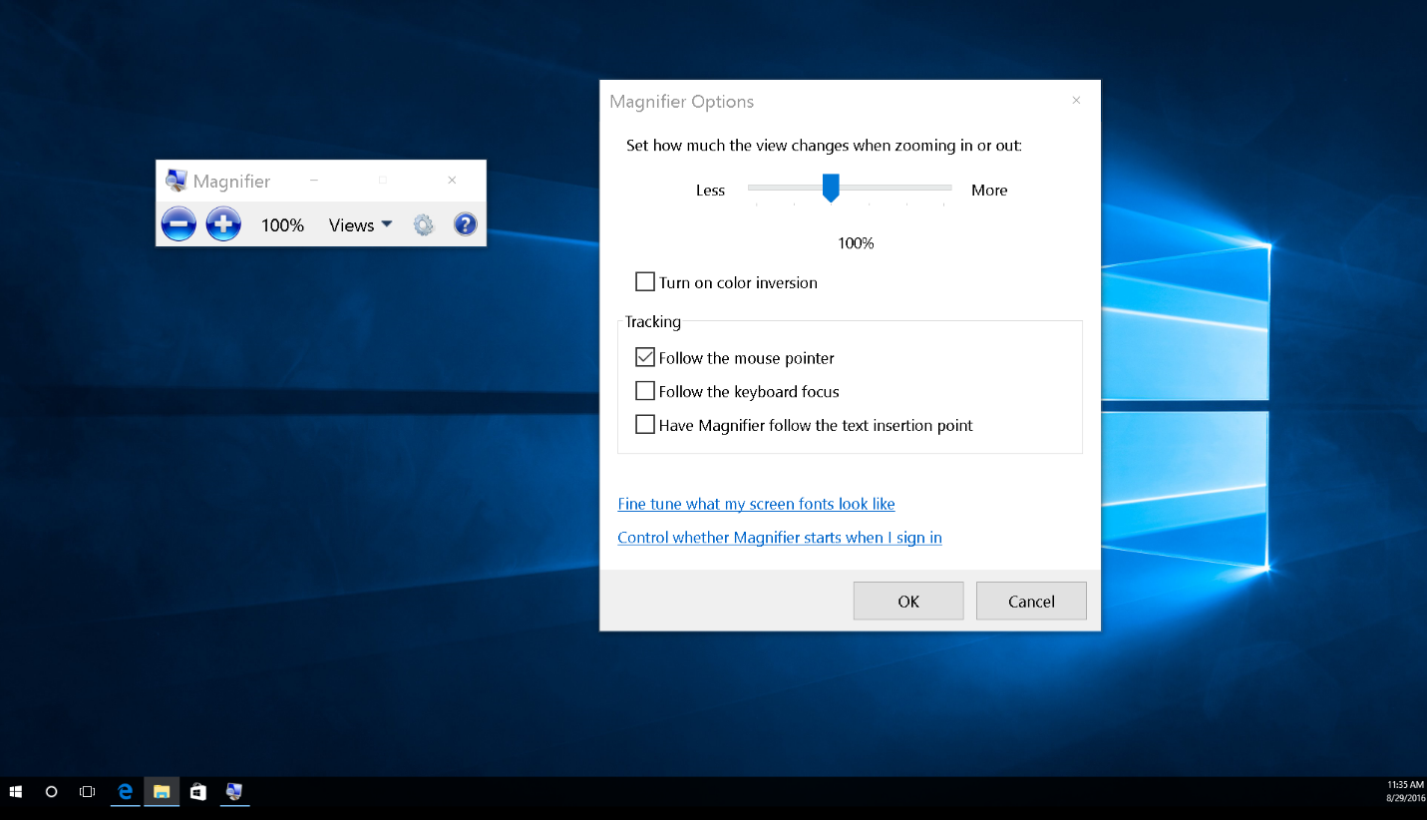

Improve visibility with high contrast
High contrast increases the color contrast between the foreground and background on your screen, making text and images more distinct and easier to identify. To turn on high contrast, press left Alt + left Shift + Print Screen.
You can choose different themes in high contrast settings. Select the Windows Logo Key + U, then select High contrast. Select a high contrast theme from the drop-down menu and select Apply.
Learn more about High Contrast
Caption 4: The calculator on the left has high contrast mode turned off, the one on the right has High Contrast Black theme

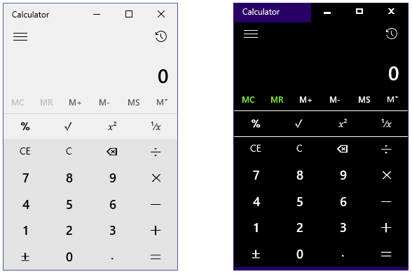

Change the size of text, apps, and other items
If text and other items on the desktop are too small, you can make them larger without changing the screen resolution or turning on Magnifier.
Open Settings with Windows Logo Key + I, then select System > Display. Under Change the size of text, apps, and other items, move the slider to your desired percentage. You may have to sign out to see changes in some apps, and this option may not be available for all displays.
Caption 5: Display options set to 125% in the Display Settings

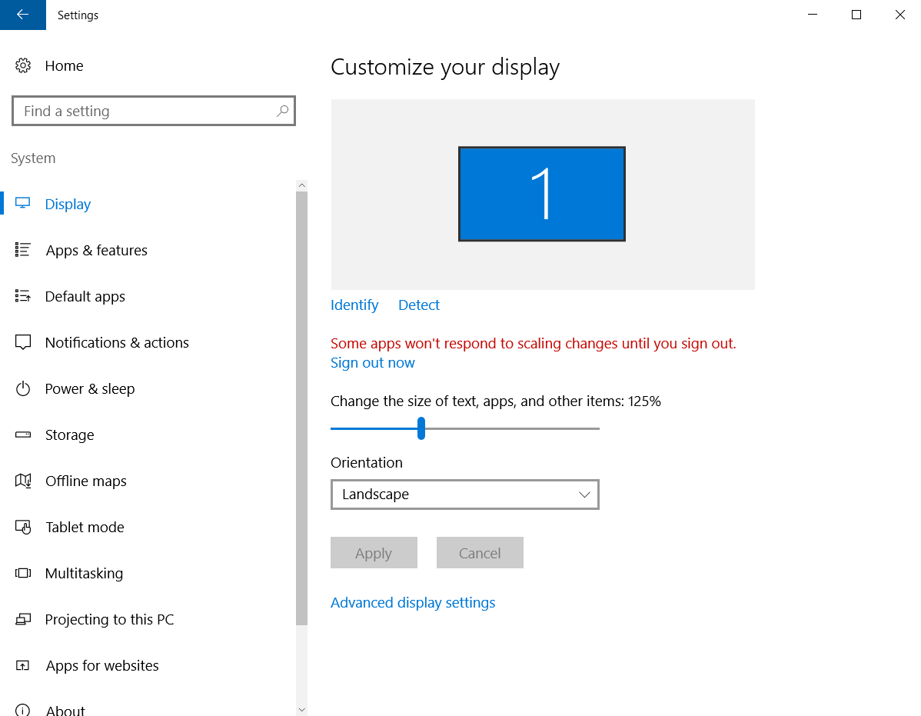

Change only the text size
You can change the text size for specific items in Windows, like window title bars and tooltips, without changing the size of anything else on the desktop.
- Press Windows Logo Key + X and select Control Panel.
- Select Appearance and Personalization > Display. Under Change only the text size, select the item you’d like to change, pick a text size, and then select Apply.
Caption 6: Display options in the Control Panel
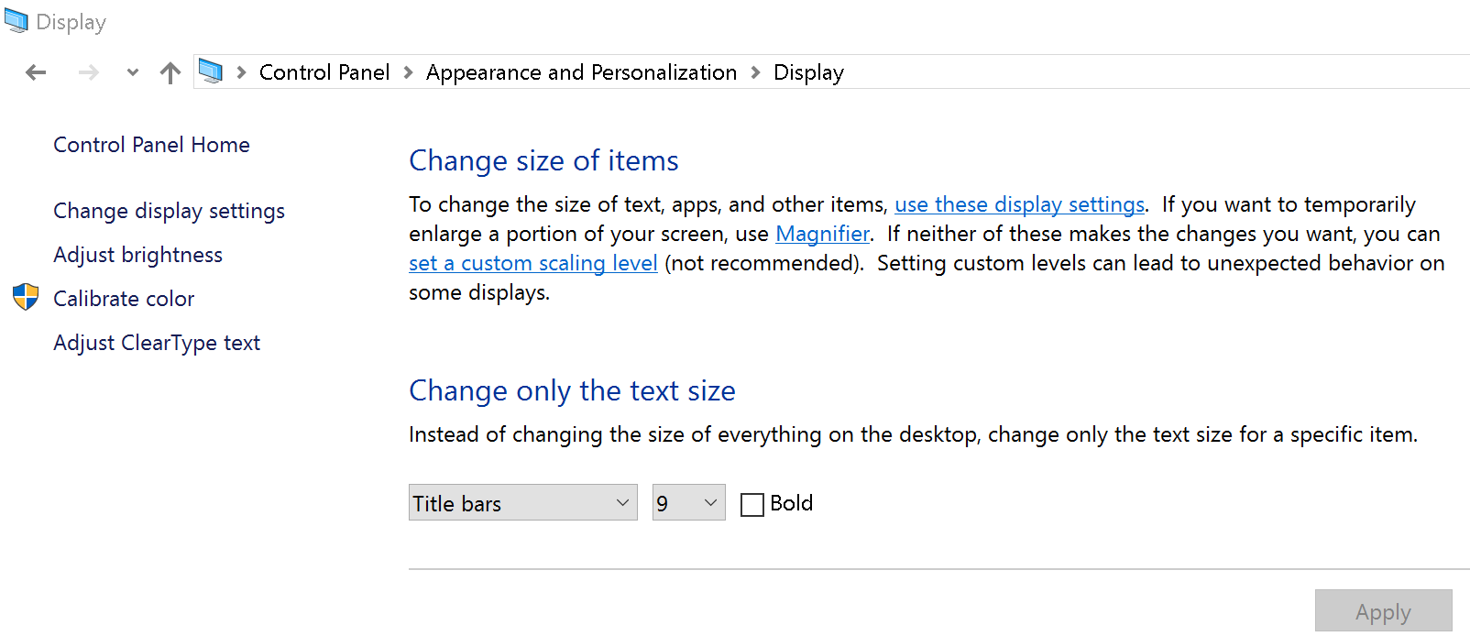

Customize sign-in settings
You can customize sign-in settings, so that accessibility features start automatically when you sign in, after you sign in, or both. To customize sign-in settings:
- Press Windows Logo Key to open Start.
- Type Ease of Access Center and select Ease of Access Center from the results.
- Select Change sign-in settings.
- Select the check boxes for the options you would like to use and then select OK.
Caption 7: A list of sign-in settings you can change in the Ease of Access Center
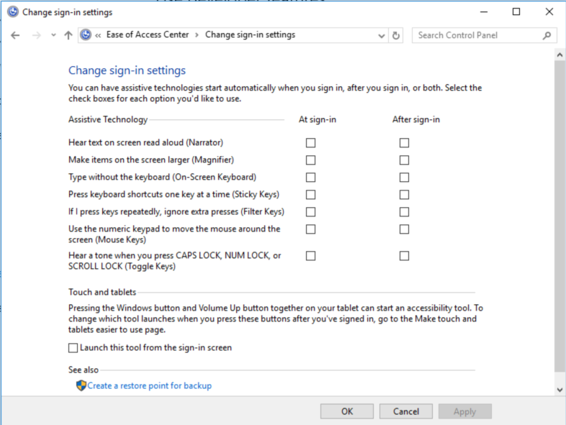

Make Accessible Documents with Office
Built-in features in Microsoft Office can help you make your documents, spreadsheets, and presentations accessible to individuals who are Blind or Low Vision. For more information on how to make your content accessible, please visit the Office Accessibility Center and Accessibility in Office 2016 and Windows 10. Check back regularly as we frequently add new articles and product tutorials.

Accessibility Checker
Word, Excel, PowerPoint, and OneNote include an Accessibility Checker that identify some content that might be inaccessible to individuals with disabilities. You can use the Accessibility Checker while you author to inspect errors as they occur and learn how to fix issues.
To Open the Accessibility Checker:
- Pres Alt + F to open the File menu.
- Select Info.
- Select Check for Issues.
- Select Check Accessibility.
Caption 8: An example of some issues found in the Accessibility Checker
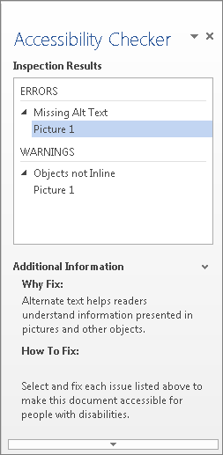
Learn more about the Accessibility Checker
Learn more about the Accessibility Checker on the Mac

Use Accessibility Features in Office
Microsoft Office comes with built-in accessibility features designed for individuals who are Blind or Low Vision. You can also customize options in Office to meet your individual vision needs and preferences.

Apply a Different Office Theme
Each Office Theme uses different foreground and background colors for the application Window, Ribbon, and Panes. You can choose the theme that meets your individual vision needs and preferences.
- Open File (Alt + F).
- Select Account.
- Select the Office Theme. (White, Colorful, Dark Grey, or Black)
Caption 9: Here is the White theme in PowerPoint 2016
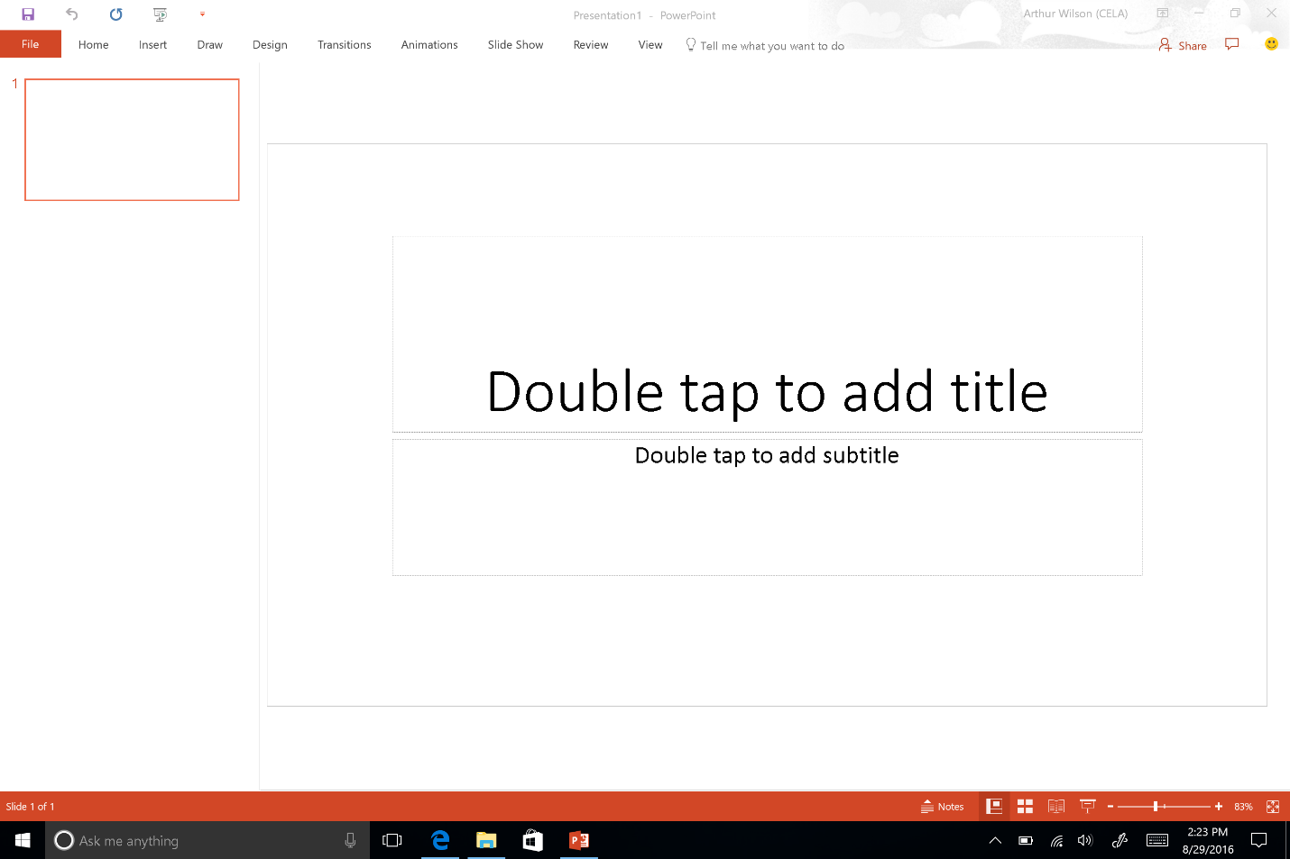
Learn more about Office Themes

Zoom In and Out of Documents
You can increase the size of pages in Word, PowerPoint slides, Excel spreadsheets and other documents in Office.
- To quickly zoom in/out press CTRL + Mouse Wheel UP/DOWN
- Alternatively, you can use the slider on the status bar to zoom in and out. You can also specify the Zoom from the View tab on the Ribbon.
Learn more about Zoom in or out of a document

Use the Speak Command for Text-to-speech
The Speak command in Office uses text-to-speech (TTS), which is the ability of your computer to play back written text as spoken words. Depending upon your configuration and installed TTS engines, you can hear most text that appears on your screen in Word, Outlook, PowerPoint, and other programs in Microsoft Office.
You can add the Speak command to the Quick Access Toolbar.
- Open File (Alt + F).
- Select Options.
- Select Quick Access Toolbar.
- Choose Commands Not in the Ribbon.
- Select Speak.
- Select Add.
- Select OK.
Caption 10: Word Options dialog box where the Speak command is selected to add to the Quick Access Toolbar
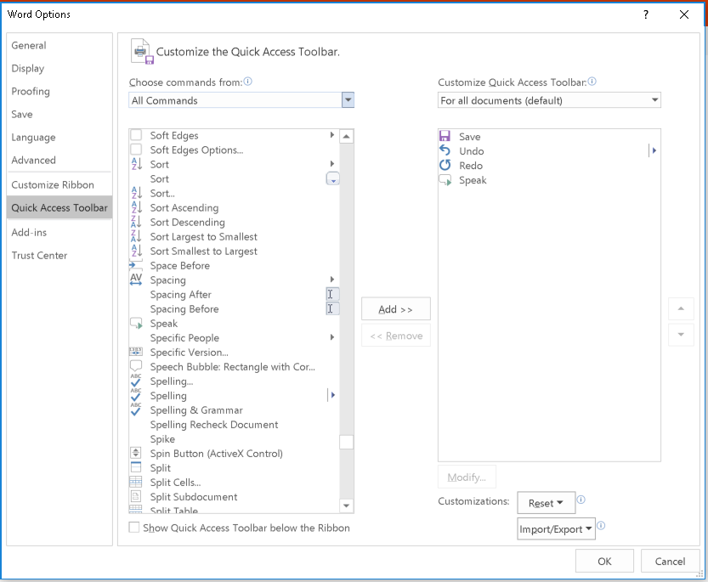
Now, you can quickly hear selected text.
- Select the text in the document you want to hear.
- Select the new Speak button in the Quick Access Toolbar.
Caption 11: Quick Access Toolbar with the Speak button activated
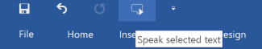
Learn more about text-to-speech

Do Things Quickly with Tell Me in Office 2016
You might have noticed a new text box on the Ribbon in Office 2016. This is Tell Me, where you can enter words or phrases about what you want to do next and quickly get to features in Office 2016.
- Press Alt + Q.
- Start typing something like “insert table” or “Accessibility Checker.”
- Select what you want to do from the list of suggestions.
Learn more about Tell Me

Get Keyboard Shortcuts and Steps for Using Assistive Technology with Office
Office for Windows, Online, Mac, iOS, Android, and Windows Mobile provides support for assistive technologies like screen readers. You can read about the accessibility features for your specific environment at the Office Accessibility Center. There you can get all the latest accessibility information on products such as Word, PowerPoint, Excel, Outlook, and even others outside of the Office Suite such as Skype or OneDrive.
- Visit the Office Accessibility Center.
- Select the app you want to learn about.
- Navigate to the section for your device.

Browse the Accessibility Features of Internet Explorer and Edge
Microsoft browsers come with built-in accessibility features designed for individuals who are Blind or Low Vision. You can also customize options in Internet Explorer and Edge to meet your individual vision needs and preferences.

Choose a Theme in Microsoft Edge
Each Edge Theme uses different foreground and background colors for the application Window and Panes. You can choose the theme that meets your individual vision needs and preferences.
- Select More.
- Select Settings.
- Choose the Dark or Light theme.
Caption 12: Here are the two theme options you can choose in Edge
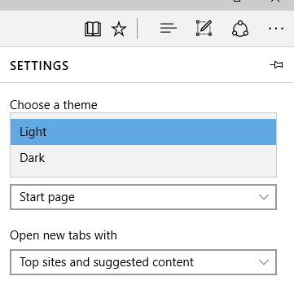

Change Your Reading View Style in Edge
The Reading list in Microsoft Edge gives you a place to save articles or other content you want to read later. You can choose the Reading view style that best meets your individual vision needs and preferences.
- Select More.
- Select Settings.
- Choose a Reading view style.
Caption 13: A Reading List in Microsoft Edge
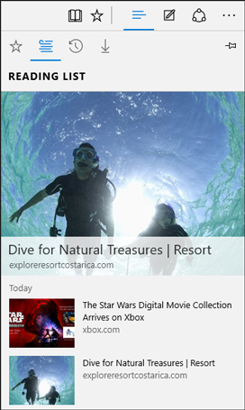
Learn more about the Reading view in Edge

Accessibility Resources with Microsoft Edge
There are several additional accessibility resources that have been developed for Microsoft Edge.
Learn more about Accessibility in Microsoft Edge

Zoom In or Out on a Webpage
Make everything on a webpage larger by zooming in. You can quickly zoom from 10% to 1000% with Edge and Internet Explorer.
- Press Ctrl and + (plus sign) to zoom in.
- Press Ctrl and – (minus sign) to zoom out.
You can specify a particular percentage to Zoom in Edge.
- Select More.
- Choose the percentage of Zoom.
You can also select a custom Zoom level in Internet Explorer.
- Press Alt + T.
- Select Zoom.
- Select Custom.
Caption 14: Custom Zoom is set to 100%
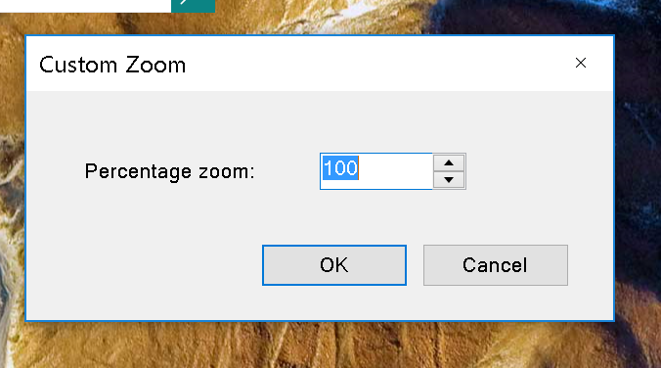

Make Text on Websites Larger with Internet Explorer
You can increase or decrease the font size on a webpage.
- Press Alt.
- Select View.
- Select Text size.
- Choose from smallest to largest.
Caption 15: Webpage open with “View” menu and “Text size: Medium” selected
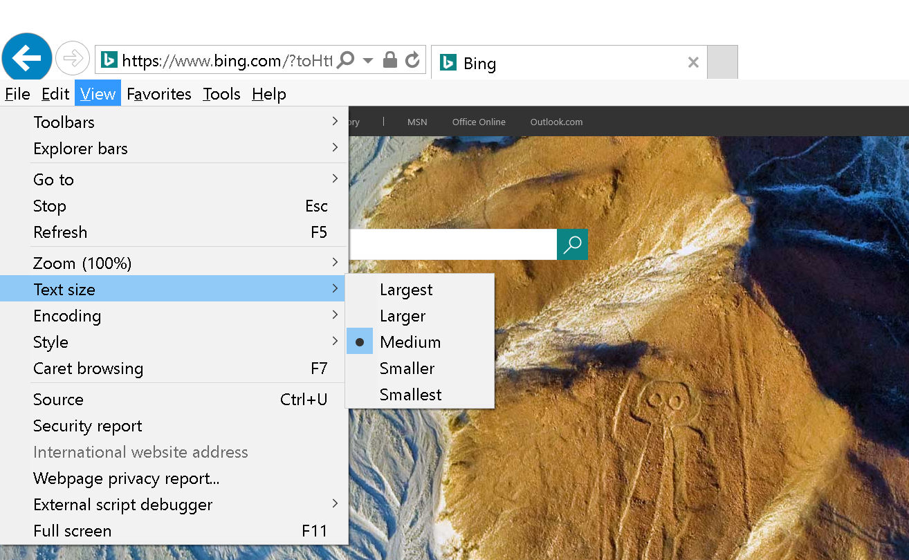

Change the Font Size, Formatting, and Colors on Webpages with Internet Explorer
You can change the font type and size, and the foreground and background colors that are used to display webpages. You can also specify the color used for links in webpages and override colors used on webpages.
- Press Alt + T.
- Select Internet Options.
- Select one of the following options:
- Fonts—to change the font type and size used on webpages
- Colors—to change the font colors used on webpages
- Accessibility—to make Internet Explorer ignore colors, font styles, and font sizes used on webpages, or to format webpages by using your own style sheet
Caption 16: Internet Options in Internet Explorer 11
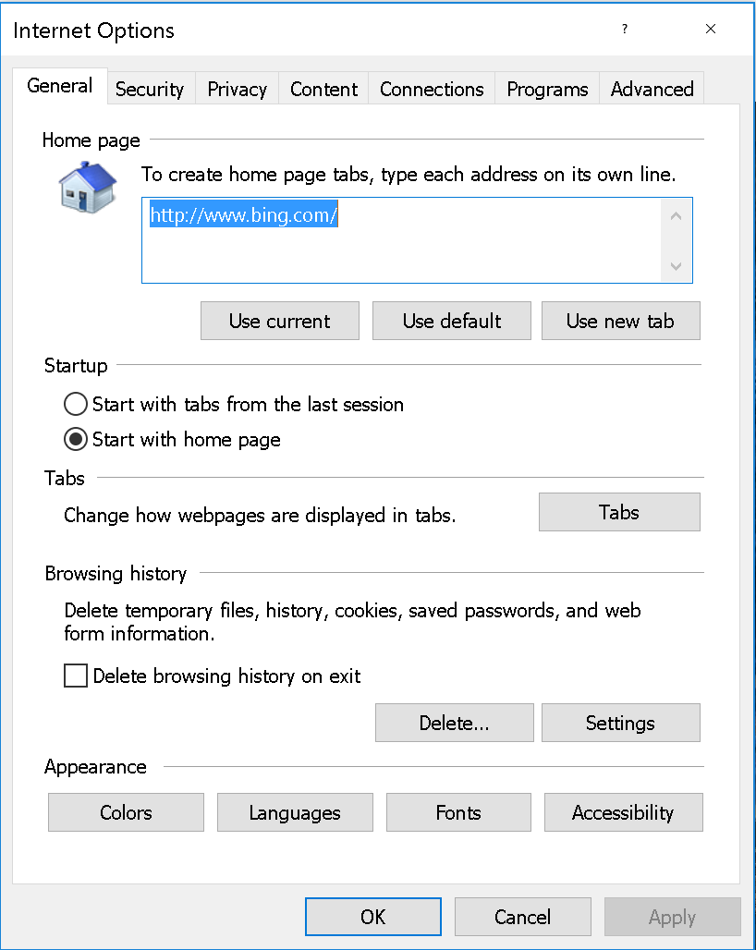

Use Internet Explorer with a Keyboard
You can use keyboard shortcuts to quickly access menu items in Internet Explorer and navigate webpages.
- Use the Tab key and Shift + Tab to move forward and backward through webpages and the address bar in Internet Explorer.
- Press the F7 key to use caret browsing to select text.
- Move around within a webpage using the standard navigation keys on your keyboard—Home, End, Page Up, Page Down, and the arrow keys.
Learn more about keyboard shortcuts for Internet Explorer

Make Internet Explorer work better with a Screen Reader or Magnifier
You can customize Internet Options in Internet Explorer to help webpages work better with your assistive technology.
- Press Alt + T.
- Select Internet options.
- Select the Advanced tab.
- Make some or all of the following changes:
- Set the cursor to determine where to read or magnify. Under Accessibility, select the Move system caret with focus/selection changes check box.
- Display text in place of pictures. Under Accessibility, select the Always expand Alt text for images check box. Under Multimedia, clear the Show pictures check box.
- Stop page transitions from causing problems with your screen reader or software. Under Browsing, clear the Use smooth scrolling check box. Under Multimedia, clear the Show pictures check box.
- Help prevent webpage sounds from interfering with your screen reader. Under Multimedia, clear the Play sounds in webpages check box.
- Select OK.
Learn more about Internet Explorer Ease of Access options

Find Assistive Technology for People who are Blind or Low Vision
Here is a list of common types of assistive technology for individuals who are Blind or Low Vision.
- Screen magnifiers work like a magnifying glass. They enlarge a portion of the screen as the user moves the focus. Magnifiers may also use very high magnification levels, font smoothing, and many color customizations.
- Screen readers are software programs that present content as speech. A screen reader is used to verbalize, or "speak," everything on the screen including names and descriptions of control buttons, menus, text, and punctuation.
- Braille printers (or embossers) are hardware that transfer computer generated text into embossed Braille output.
- Braille translation software programs convert text scanned in or generated via standard word processing program into a format that can be printed with a Braille printer.
- Braille displays provide tactile output of information represented on the computer screen. The user reads the Braille letters with his or her fingers, and then, after a line is read, refreshes the display to read the next line.
- Braille notetakers enable a person who is blind to capture notes and then transfer them to a PC. Braille notetakers take advantage of refreshable Braille technology. In some cases, Braille notetakers replace or supplement a standard keyboard.
- Book readers. Some people use a PC configuration for book reading assistance, or a dedicated reading device. Books are available in digital formats through various commercial and nonprofit organizations.
- Optical Character Recognition (OCR) software programs convert images of text into digital text characters. A person who is Blind or Low Vision might have printed material scanned and read aloud through a text-to-speech software program on the PC.
Learn more about Assistive Technology products for Windows
Guide last updated on 2/7/2017.

